ABN: |  | Invoice:
C/- developer name.  C/- Contact person |  | Date: | 16/02/2018
Your Ref: |  | Via Email: | Email address

MEMORANDUM OF FEES / TAX INVOICE
RE: Enter the reference of the invoice
Date | Description | Amount
Enter the date. |  | $Enter the amount
Enter the date. |  | $ Enter the amount
Enter the date. |  | $ Enter the amount
With Compliments, | Sub-Total | $ Enter subtotal
 | GST Total | $ Enter GST amount
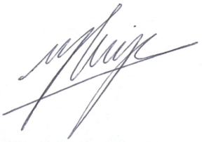  Mercier Body Corporate Developments | TOTAL (incl. GST)  Payable within 7 days  National Australia Bank  Account Name: Marc Mercier  BSB: 084399  Account: 638960094  ABN: 74 571 464 618 | $ Enter the total

