Introducing MBCS new online services
About Mercier Body Corporate Services (MBCS)
MBCS is a Queensland-based Body Corporate Management Company consisting of a highly skilled team of professionals that have a passion for strata management, strata communities and strata law. Our services are centred around the needs of committees, lot owners and Resident Unit Managers for timely response, compliance, expert legislative advice and support. We love what we do and apply our expertise to bring lot owners cutting edge strata industry innovation, expert advice on strata matters, and systems that help save time, money and effort.

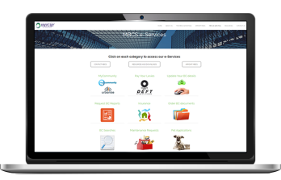
Access our online services:
mercierbcs.com.au/eservices

Access our e-Learning and resources:
mercierbcs.com.au/resources
At MBCS, we have created a platform in our website for lot owners to manage their strata-related tasks, all in one convenient place. In addition to mercierbcs.com.au website, our Strata e-Services mobile App for iPhone and Android devices is your little Body Corporate helper in your pocket.

Online Services via MBCS Website and Strata e-Services App
1

- Online Insurance claims and information  - Emailed levies (if opt- in)  - Update BC details | - Order documentation  - Body Corporate searches  - Owner e-requests | - Report requests:
 |  | - Asbestos  - Fire Audit  - WPHS | - Sinking Fund Forecast  - Insurance Valuation  - Safety Audi
Online requests and forms
2

- Pet applications  - Loss of discount & penalty applications | - Maintenance applications  - Renovation/Improvement requests | - Complaints handling  - General requests
Online payments
3

- Levies via Macquarie Bank portal  4  e-Learning | - Body Corporate searches and order documentation

Our e-learning platform assists you to more easily locate answers to your Body Corporate queries, because we know it can be difficult to find information in the Legislation,

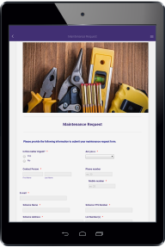
Strata e-Services app
Download on App Store or Google Play
1300 882 072
(07) 3833 6808
contactus@mercierbcs.com.au

www.mercierbcs.com.au

1300 882 072
(07) 3833 6808
contactus@mercierbcs.com.au

www.mercierbcs.com.au
We’re only ever a click on your device, phone call, or email away.

