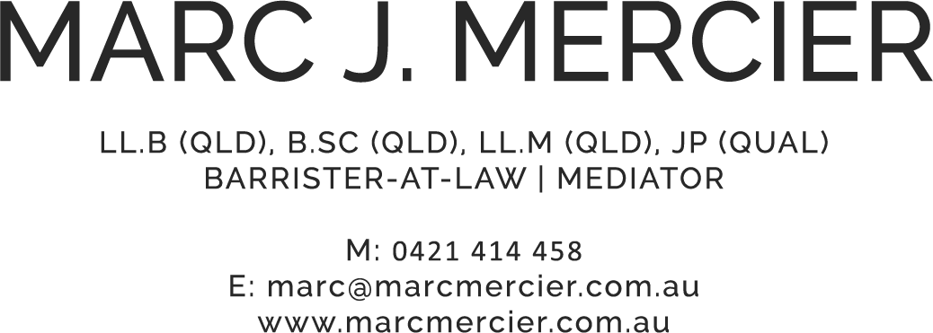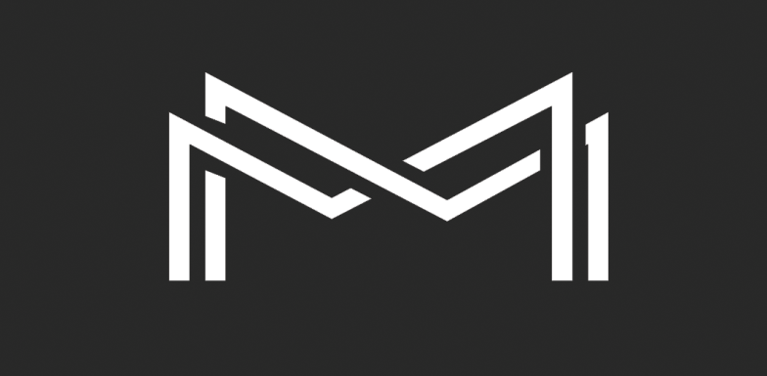

COSTS DISCLOSURE NOTICE & AGREEMENT (DIRECT ACCESS)

Click here to enter a date.

Ver. 1.